Steps：

1. ls –li file1.txt
2. ln file1.txt file2.txt
3. ls –li file2.txt
4. rm file1.txt
5. strace rm file2.txt
6. ln –s file3.txt file4.txt
7. ls –li file3.txt
8. ls –li file4.txt

Snapshots：

Hardlinks：

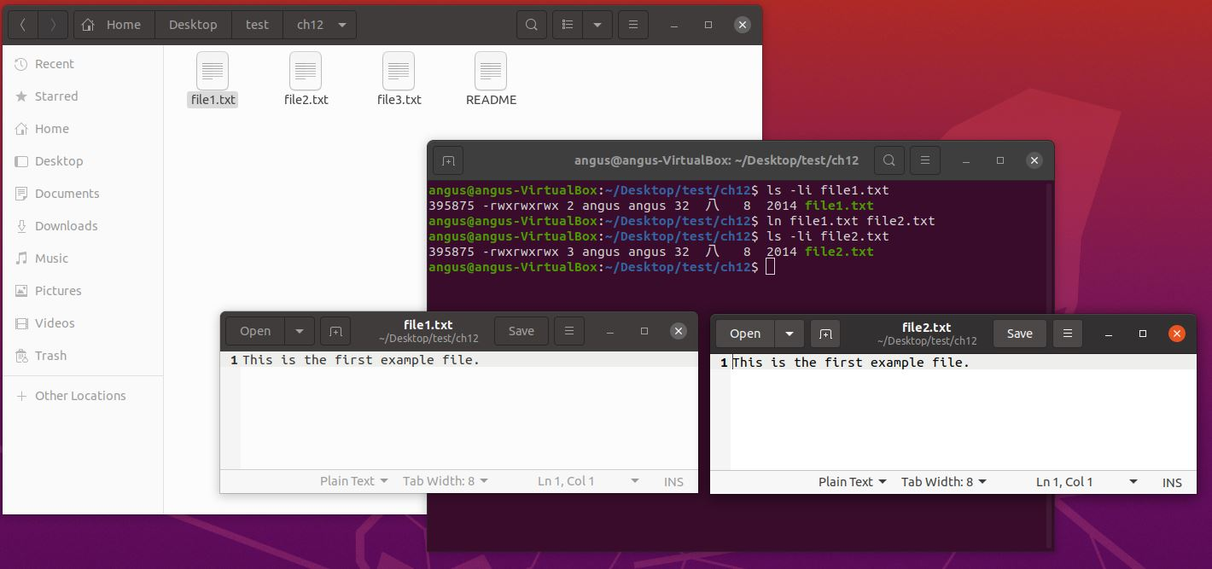

What are the inode values of file1.txt and file2.txt? Are they the same or different? Do the two files have the same—or different—contents?

The inode value for the two files are the same, and the contents are the same.

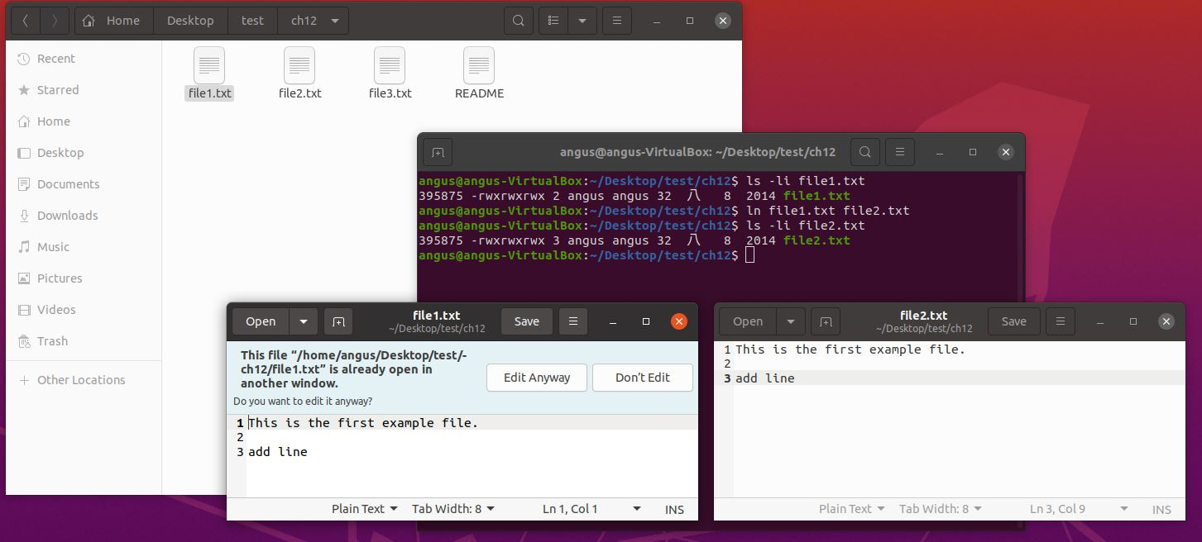

Next, edit file2.txt and change its contents. After you have done so, examine the contents of file1.txt. Are the contents of file1.txt and file2.txt the same or different?

After edit file2.txt the content in file1.txt also changed, they are the same.

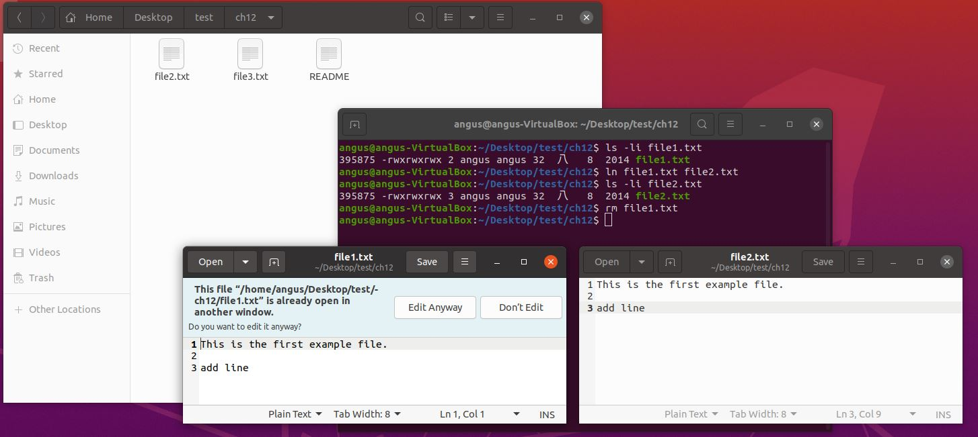

Does file2.txt still exist as well?

file2.txt still exist after removing file1.txt.

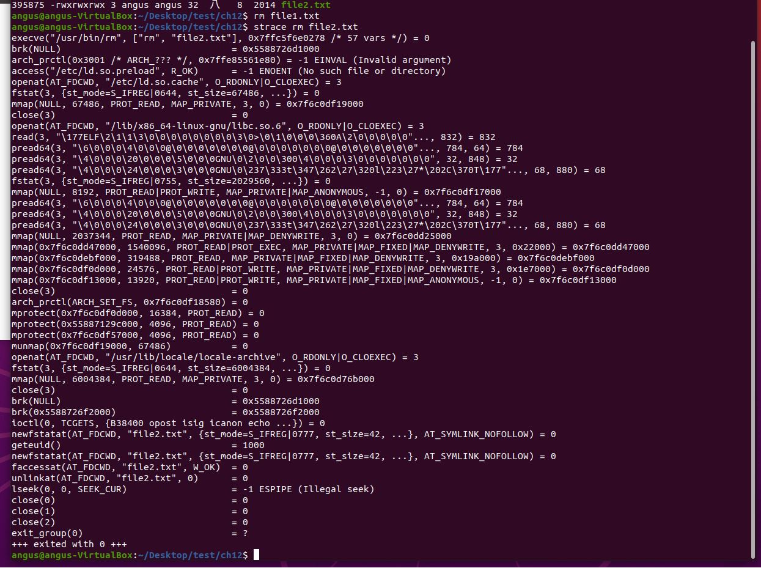

What system call is used for removing file2.txt?

System call use unlink to remove the file.

Softlinks：

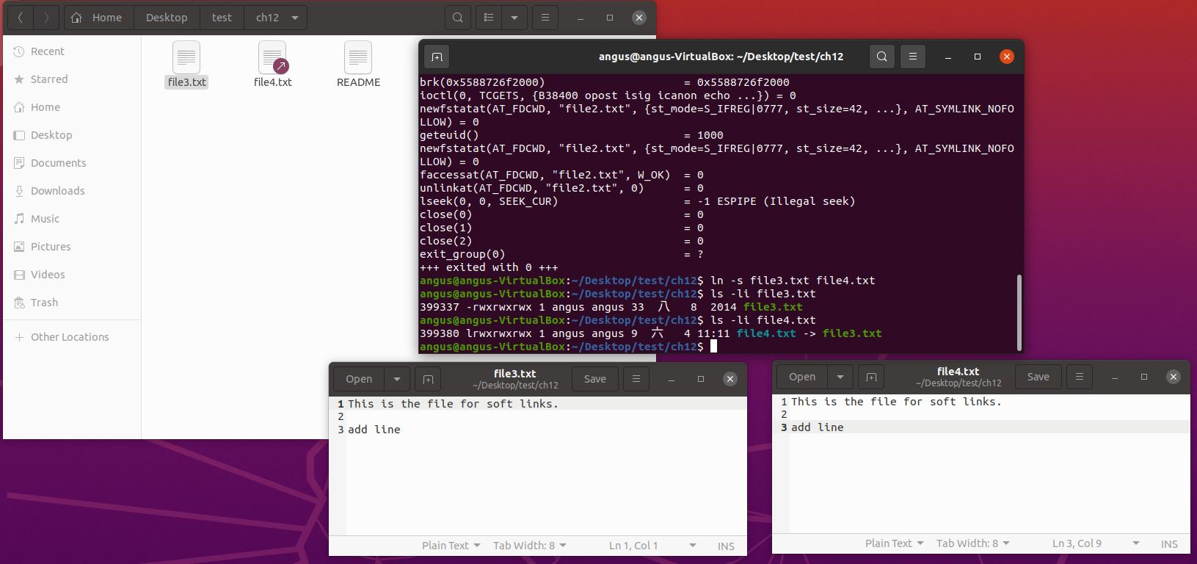

Are the inodes the same, or is each unique? Next, edit the contents of file4.txt. Have the contents of file3.txt been altered as well? Last, delete file3.txt. After you have done so, explain what happens when you attempt to edit file4.txt

The inodes for the two files are not the same, however, after editing the contents of file4.txt the contents of file3.txt also changed.

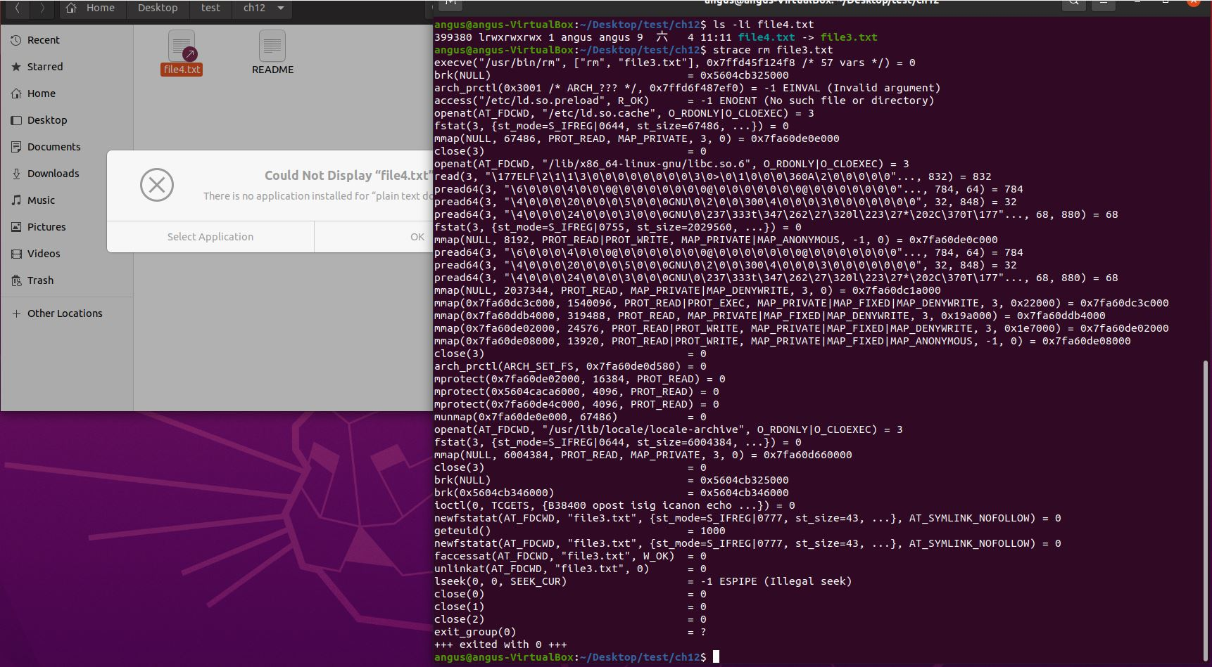

After deleted file3.txt the softlink still exist, yet we cannot access file4.txt